4.45: a)
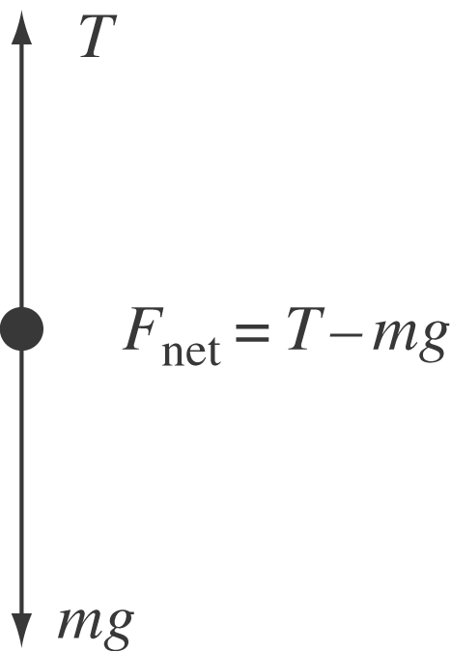
The maximum acceleration would occur when the tension in the cables is a maximum,

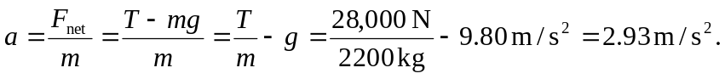

b) 